Big data analysis in genomics

Home work assignment II

WGBS data analysis

Table of Contents
Instructions and other information 2
Formal Requirements and Rules 2
Submission and filling information 2
How to get help 2
Evaluation criteria 3
General information about your samples and analysis 4
Data pre-processing 5
Getting datasets 5
Raw data QC and methylation calling 5
Data QC and statistical analysis 7
7
DMC calling 8
DMR calling 9
Biological interpretation 1
1
Conclusions 1

Instructions and other information
This document describes the execution and tasks of your second homework assignment.
Formal Requirements and Rules
- All data files and code must be stored on the university computer (remote machine).
If you perform any analysis on your personal computer, you must transfer all files and results to the remote machine.
- You must complete the assignment independently. You can ask others (classmates, online resources, or LLMs) for help, but they can't do any part of the assignment for you. You are fully responsible for the submitted work and must understand everything you submit.
- Your code and metadata (only code, plots, and metadata – no raw/processed data) must be submitted to your GitHub.
- Your GIT must have a README.md file. There should be a project description, data description, software and packages used, and an explanation of how to reproduce the analysis.
- All analysis steps must be clearly documented.
  - Code, commands, and parameters should be included where appropriate. If you perform something online (you can do that) – you must write what tools you used and how you used them.
  - Results must be reproducible using the provided files and descriptions.
Submission and filling information
- Follow the document structure and complete as many sections as possible.
- Wherever an answer is required, you will see a text box labeled “Write your answer here."
- Any text shown in red (including headers) must also be completed.
- After finishing, make a pdf of this document and submit it to Emokymai system.
- If you don’t know how to do some parts – ask Kotryna for help.
How to get help
- At least 50% of the assignment will be completed during lectures. We will use different datasets, but the analysis steps will be very similar. Therefore, active participation in lectures is strongly recommended.
- If you have questions, you may contact your lecturer. You can reach Kotryna by email or via Teams. When writing, please:
  - clearly describe your problem
  - explain what you have already tried
You may write at any time (including evenings or weekends). Kotryna will reply as soon as possible.
- You are encouraged to discuss problems in groups and work together on understanding the tasks. Explaining a problem often helps solve it. However, the final analysis must be performed using your own data and completed by you.
- If you are stuck and don’t want to continue solving some specific problem but need a specific file to continue your homework – ask Kotryna for the intermediate file. You'll get points for what you did, but not for what you skipped.
Evaluation criteria
- Correct execution of analysis steps
- Clarity of explanations
- Biological interpretation of results
- Reproducibility and organization
- Demonstrated understanding of the methods
- Not all analyses will work perfectly for each of you – this is normal. Reasonable attempts and clear explanations are valued beyond perfect output.

General information about your samples and analysis
Please answer the following questions based on your assigned dataset and the corresponding publication. When in doubt, explain your reasoning.
- Indicate your samples. List the sample IDs exactly as provided.
GSM4505856
GSM4505857
GSM4505866
GSM4505867

- What sample groups are present? Describe your groups: what they represent biologically, and why they are important for the study
GSM4505856 – normal N1 WGBS
GSM4505857 – normal N2 WGBS
GSM4505866 – Tumor T1 WGBS
GSM4505867 – Tumor T2 WGBS
Two normal (healthy cells) and two esophageal squamous cell carcinoma (tumour cells). Number indicates replica (patient).

- What tools did the authors use for read mapping, bisulfite calling, and statistical analysis?
Read mapping - trimmed reads were aligned to the HG19 reference genome using BSMAP (v2.89) with the option of “-p 8 -R”;
Bisulfite calling - MOABS (v. 1.3.4);
Statistical analysis - MOABS (for DMC), LOLA package (R) for DMR;

- What were the main findings related to your specific samples/samples group? Focus on results that directly involve the samples you are analyzing.
Cancer group was compared to non cancer, more than 5 million significantly differentially methylated cytosines (DMC) were identified. More than a half of those were located on annotated regions. 97.3 % of DMC were hypomethylated, mostly in intragenic regions. 653 % of hypomethylated DMCs mapped to lncRNA regions. Hypermethylation was rare but targeted – in gene bodies, promoter, enhancers and CpG islands. 58 % of hypermethylated DMCs were in antisense RNA regions of the genome. Overall this shows massive epigenetic remodeling in ESCC, which is expected. In the DMR analysis it was found that there was a higher methylation variance in tumours, clinically – patients with lower methylation variance had a better survival, suggesting that methylation patterns have a prognostic value.

- What hypothesis could be answered using your samples?
Two biological repeats wouldn‘t give a very reliable answer, but it is enough to explore how methylation changes in tumour, specifically in CpG‘s, regulatory zones. It is expected for ESCC tumour to have a distinct methylation pattern compared to the normal tissue, particulary in regulatory regions.

- What type of sequencing was performed? Indicate whether it was paired-end or single-end sequencing and library type.
Sequencing – Illumina, paired-end
Library type – Fragmented DNA (~300bp fragments) with adaptors ligated to both ends. Bisulfite conversion performed to the whole genome. Then PCR amplification and purification were carried out.

- How many reads do your samples contain on average? Report approximate values and specify units if needed.
Sample Name | Seqs
SRR11647648_1 | 379.0M
SRR11647648_2 | 379.0M
SRR11647649_1 | 369.8M
SRR11647649_2 | 369.8M
SRR11647658_1 | 357.4M
SRR11647658_2 | 357.4M
SRR11647659_1 | 359.5M
SRR11647659_2 | 359.5M

- Provide the link to your public Git repository. This repository must contain all code used in your analysis.
https://github.com/augustezz/Homework2

- Provide the IP address of the remote computer. This IP address should be the machine where your analysis was performed.

10.113.13.111 172.17.0.1
Data pre-processing
Getting datasets
- On the remote machine, create a directory named HW2. All files related to this homework must be stored in this directory.
- Inside the HW2 directory, create two subdirectories: “raw_data” and “references”.
- Download your sequencing samples into the raw_data directory.
- Index the reference genome using the appropriate tool. You don’t have to redownload the reference genome - you can use the FASTA file from your HW1. Copy it from there or if you know how to make links - use a link.
Raw data QC and methylation calling
If a step fails or produces unexpected results, describe the issue and explain how you investigated it.
- Perform quality control (QC) on the raw sequencing data. Describe the QC results. If necessary, clean or filter the data. Justify all actions taken (what you did and why), or explain why no cleanup was needed.
Read quality – mean quality scores were good (Phred above 30) for each sample.
Per base sequence content – as expected in WGBS, due to bisulfite conversion in forward reads C = 1 %, T = ~50 % (converted), while in reverse reads G = 1%, A = ~50 %.
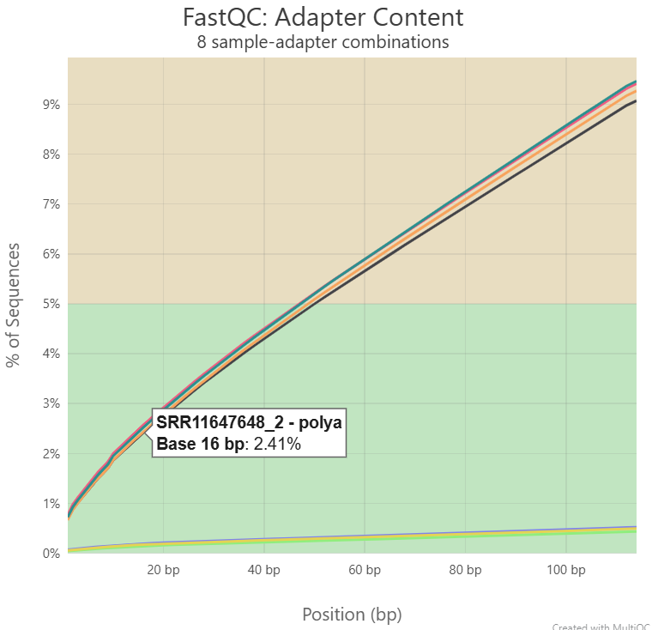
Adapter contamination – forward reads showed very low adapter content (~0.5 %) while reverse reads contained adapter contamination (reaching 9 % at the end of the read). The gradual increase in adapter content towards the 3’ end in reverse reads, and indicates that some DNA fragments were shorter than the read length. There was also polyA sequence overrepresentation in reverse reads. Therefore, adapter trimming was performed using trim-galore. Trimming report indicated that between 34-50 % of reads contained adapter sequences with reverse reads showing higher adaptert content than forward reads. Trimming was minimal - ~99 % of bases retained after trimming.

Duplication rates – for each sample, less than 20% of fragments were duplicated.

- Report the number of reads used for mapping.
Sample Name | Seqs
SRR11647648_1_val_1 | 379.0M
SRR11647648_2_val_2 | 379.0M
SRR11647649_1_val_1 | 369.8M
SRR11647649_2_val_2 | 369.8M
SRR11647658_1_val_1 | 357.4M
SRR11647658_2_val_2 | 357.4M
SRR11647659_1_val_1 | 359.5M
SRR11647659_2_val_2 | 359.5M

- Map the reads using an appropriate aligner. State which mapper you used and justify your choice. Describe the key mapping parameters and options you used
Reads were mapped to the human reference genome (GRCh37/hg19) using BSMAP v2.89.
Used parameters: -a and -b for paired end input files, -d for the reference genome, -o for the BAM output file and -p 6 to utilitize 6 parallel threads for faster processing.

for sample in SRR11647648 SRR11647649 SRR11647658 SRR11647659; do
bsmap -a ${sample}_1_val_1.fq.gz -b ${sample}_2_val_2.fq.gz \
-d ~/homework2/references/Homo_sapiens.GRCh37.dna.primary_assembly.fa \
-o ~/homework2/mapped/${sample}.bam \
-p 6
done

- Calculate/get duplication rates for your samples. If appropriate, deduplicate your data.
SRR11647648: 6.7%
SRR11647649: 13.7%
SRR11647658: 6.5%
SRR11647659: 10.2%
All duplication rates below 20 % so no deduplication was performed.

- Create a plot (using any tool of your choice) showing the mapping rate for each sample and duplicates per sample. Describe and interpret the results.
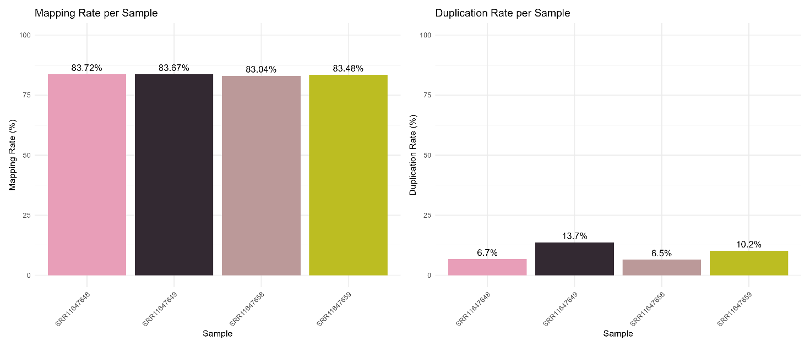
Mapping rates were consistent between the samples suggesting uniform library quality and no major sequencing issues. Duplication rates vary more, notably in the reverse samples, however all rates were below 20 % which is acceptable for WGBS.

- Plot and discuss M-bias plot
M-bias plots were generated using MethylDackel for each sample on chromosome 20. Both Original Top (OT) and Original Bottom (OB) strands were examined. Overall, methylation levels were stable across the middle portion of reads. However, Read 2 showed clear methylation bias at the ends of reads on both strands, with dramatic drops visible at the 3' end of OT and 5' end of OB strands, meaning that reverse strand 3‘ end is problematic. Read 1 remained relatively consistent across all positions. To correct for this, sample-specific trimming parameters (--OT and --OB) were applied during methylation extraction using MethylDackel.
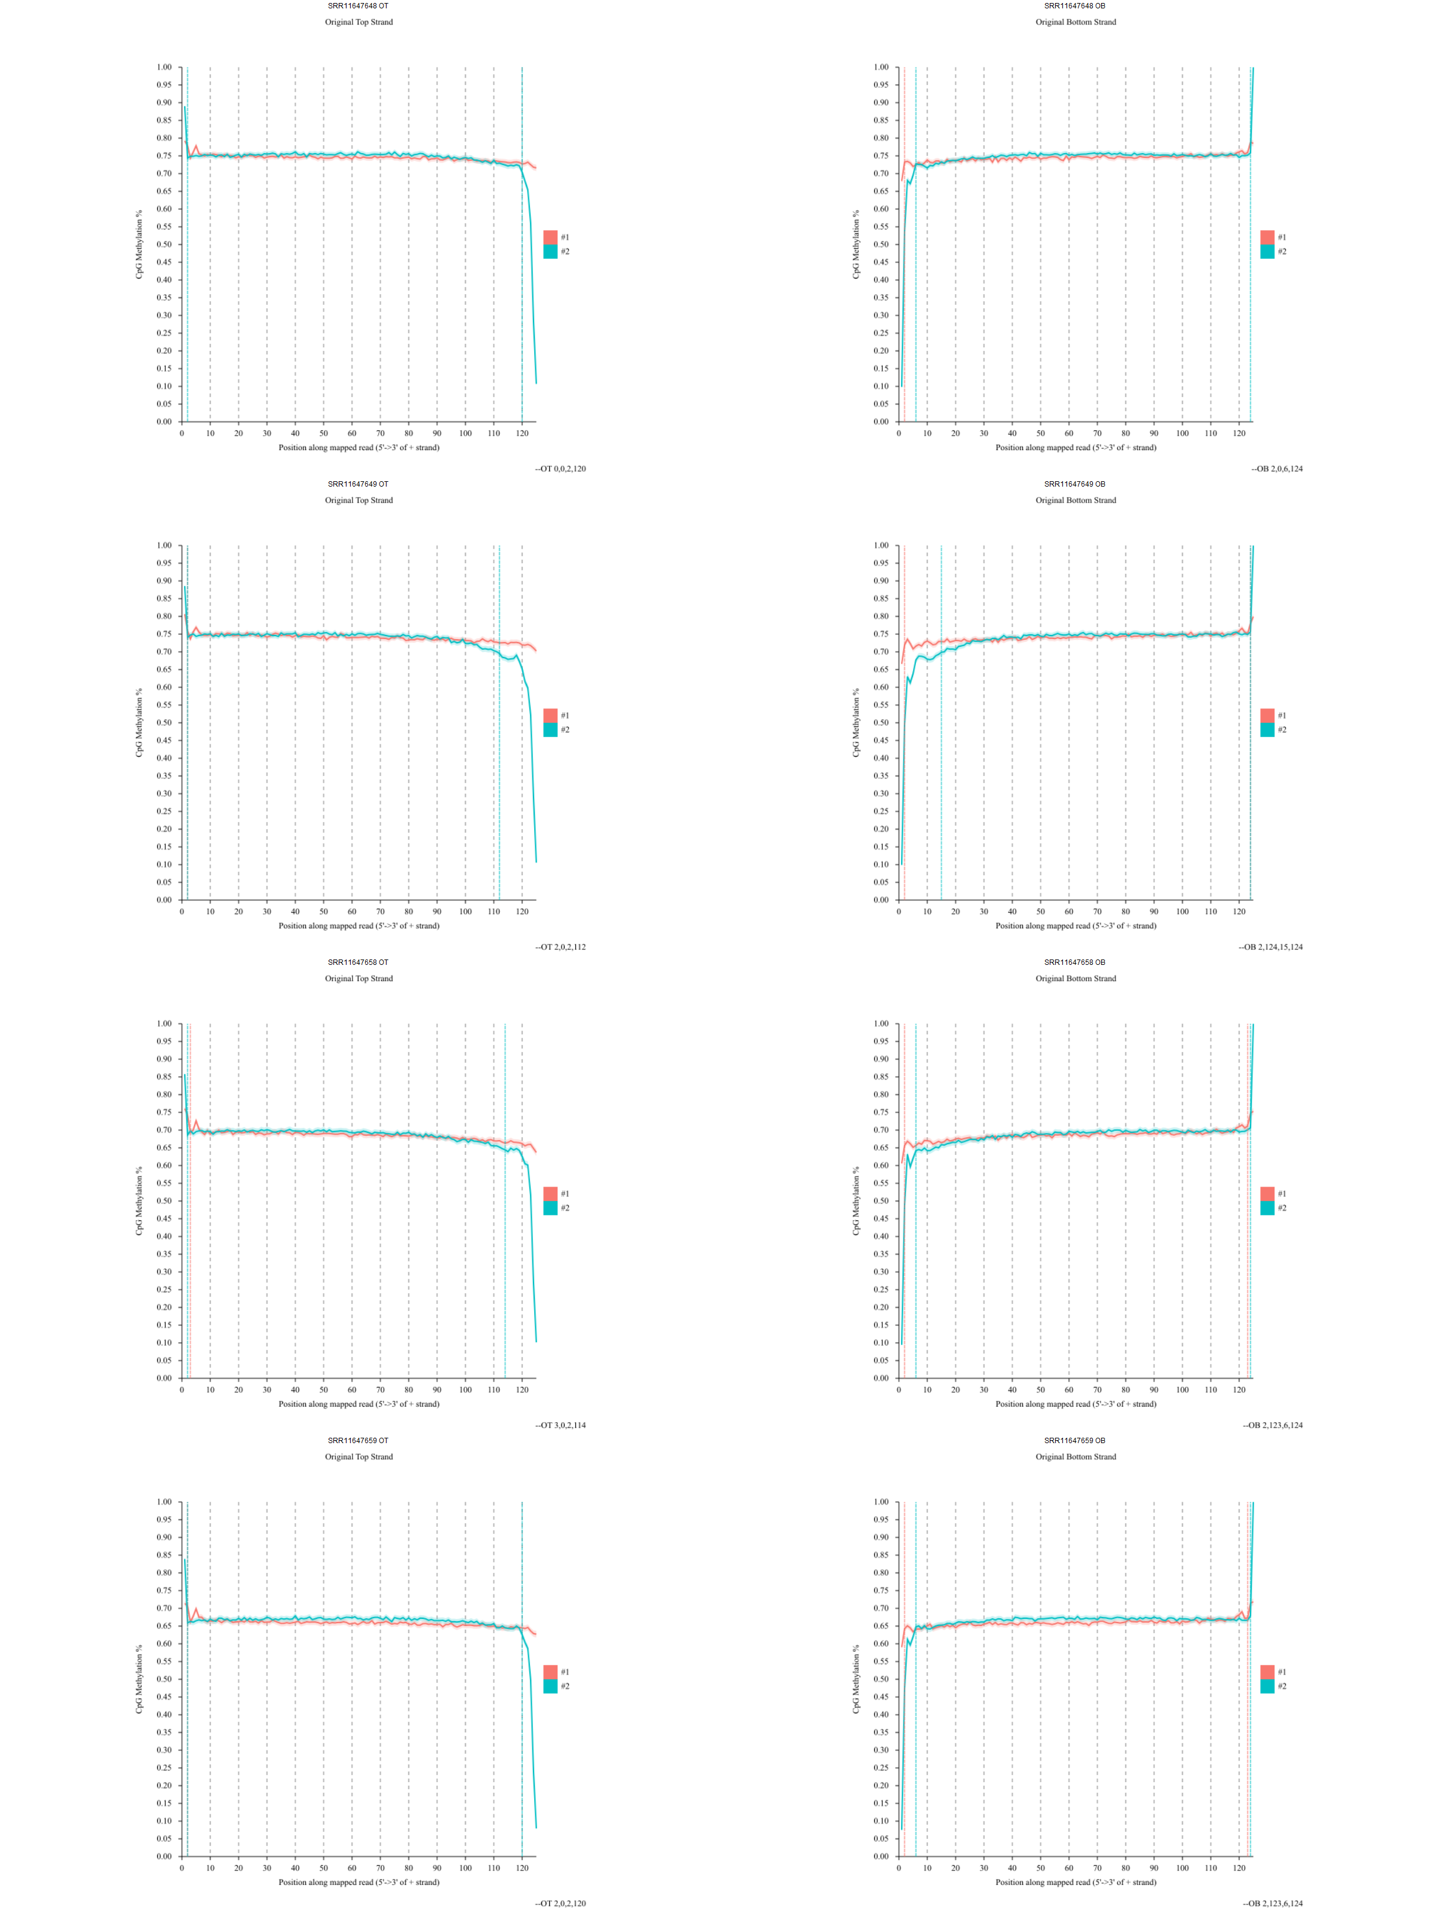
- Perform methylation calling. Describe tools that you used and their parameters.
MethylDackel extract was used for methylation calling.
Parameters:
--OT based on m-bias
--OB based on m-bias
-r chr 20
-o output

- Don’t forget to include all the codes and results plots (like fastqc, multiQC, etc.) in your GIT repo.
Data QC and statistical analysis
Using a tool you like (not limited to R):
- Calculate and report:
  - total number of reads per sample,
Total reads per sample:
SRR11647648: 12,534,200
SRR11647649: 11,281,099
SRR11647658: 11,767,478
SRR11647659: 13,356,901

  - coverage distribution per CpG,
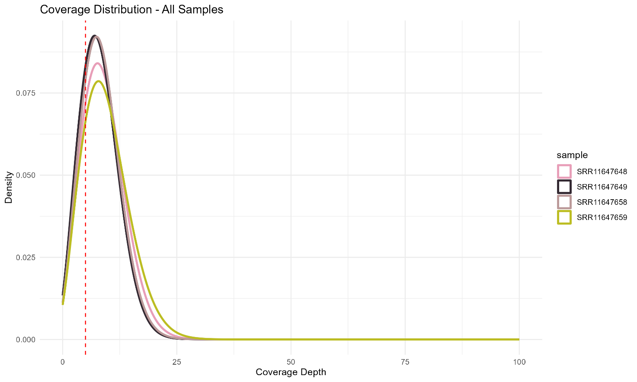

  - number of covered CpGs per sample.
sample | total_reads | covered_CpGs
SRR11647648 | 12,534,200 | 1,411,869
SRR11647649 | 11,281,099 | 1,407,695
SRR11647658 | 11,767,478 | 1,412,279
SRR11647659 | 13,356,901 | 1,412,353

- Discuss if anything looks abnormal and identify the lowest-quality sample.
No abnormalities were observed across samples. Lowest quality sample seems to be - SRR11647649, it has the highest duplication rate (13%), and a slightly smaller covered CpG rate.
- Create a correlation plot (Pearson correlation) between samples using methylation levels. Provide the plot and explain what it shows.
All samples correlate well (0.7-0.79) which means methylation patterns in a broad sense are similar – they are all human. Highest correlation was observed in healthy tissue between different donors, second highest – between tumour samples in different donors. Normal-tumour correlations are lower than within-group correlations. This shows significant methylation differrences in cancer – it changed so much that correlation between different donors is bigger than between different conditions. Also notable that tumour-tumour correlation is lower than normal-normal, since tumour modifications are usually heterogenic. Overall, biologically, observed correlation makes sense.
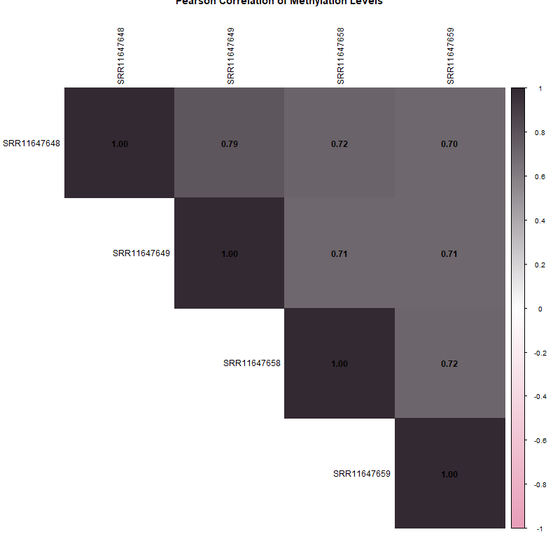
- Perform PCA analysis using methylation data. Provide the PCA plot and explain the clustering pattern.
Results explain similar biological idea as the correlation heatmap. Healthy samples are more similar and cluster on the left side, while tumour samples are very separated. It seems that PC1 (38.7 %) explains healthy-tumour difference while PC2 (34 %) captures within-group (donor) differences. Again, this is consistent with known tumor methylation heterogeneity – normal tissues are epigenetically more homogeneous across individuals while tumors show greater inter-individual variability.

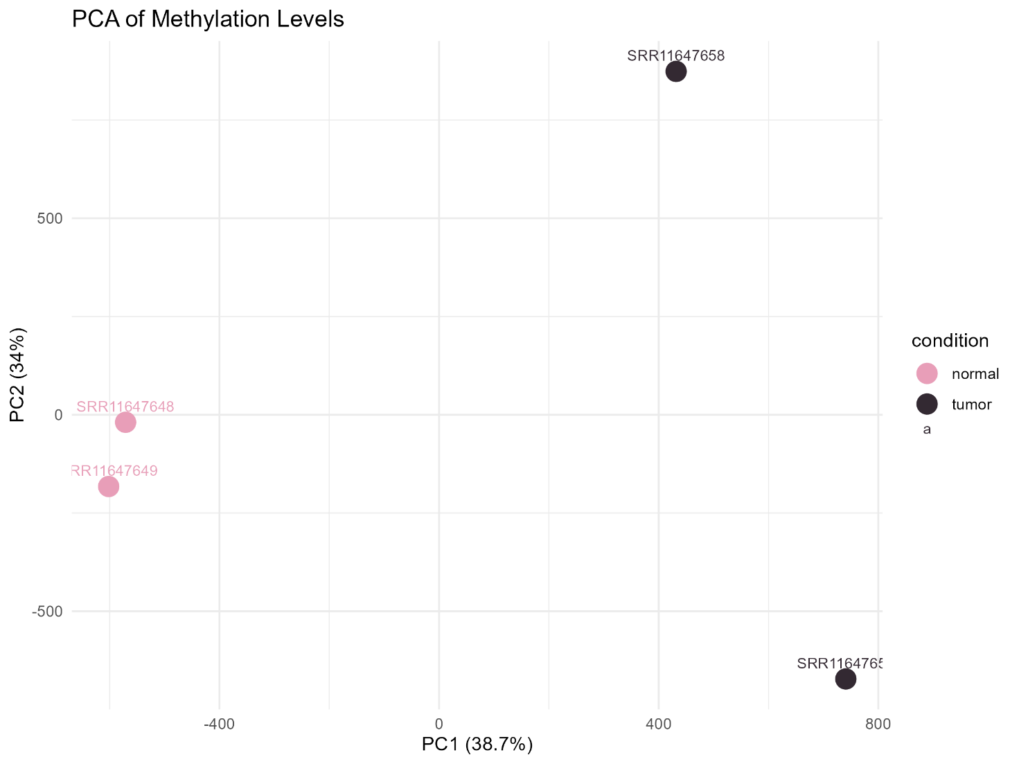
- Rerun PCA with different filtering (≥5x, ≥15x, ≥20x coverage). How does filtering affect sample clustering? Create a comparison figure and explain it.
With bigger coverage we also lose CpGs so the variance decrases. Most apropriate treshold would be 5x
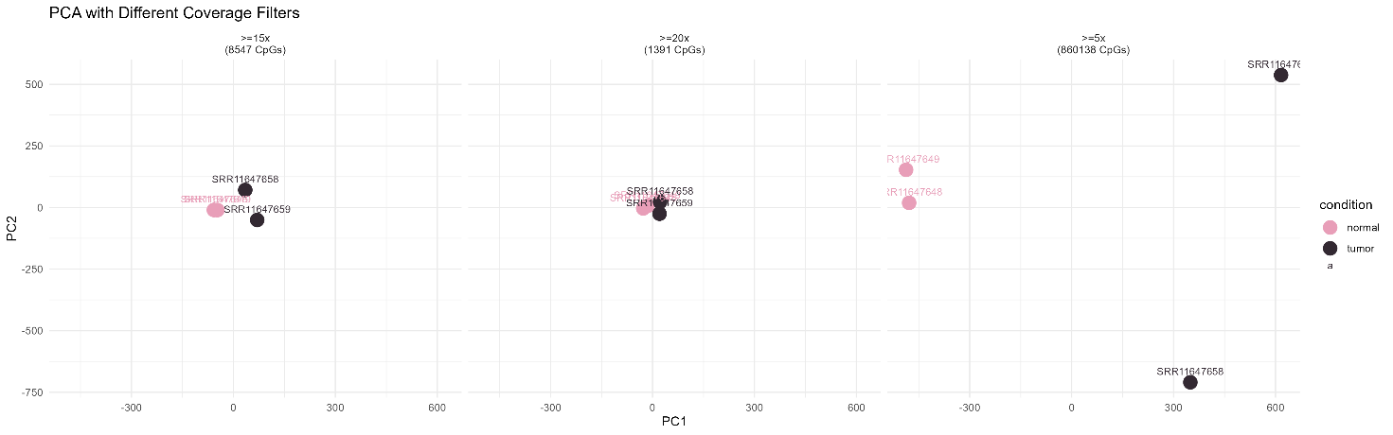
- Visualize coverage distribution across samples.
Discuss potential biases (e.g., uneven coverage, low coverage CpGs).
- Low coverage CpGs – 5x coverage treshold should be used to avoid unreliable methylation estimates, as few reads cannot accurately represent true methylation level.
- Uneven coverage – coverage is more or less similar across samples
- Right tail – no right tail observed
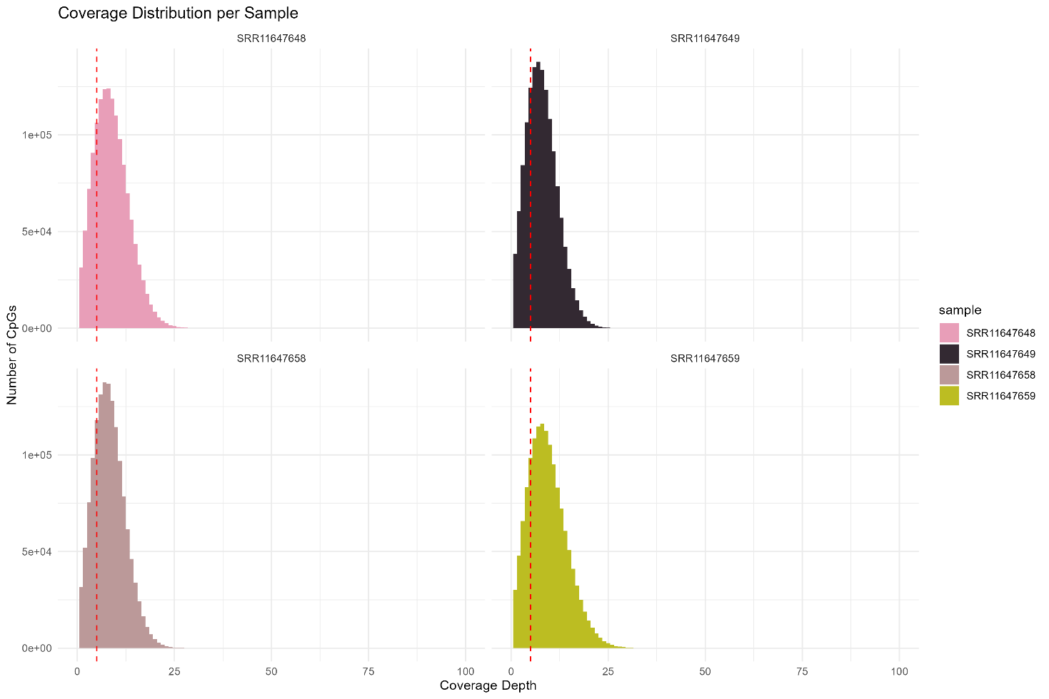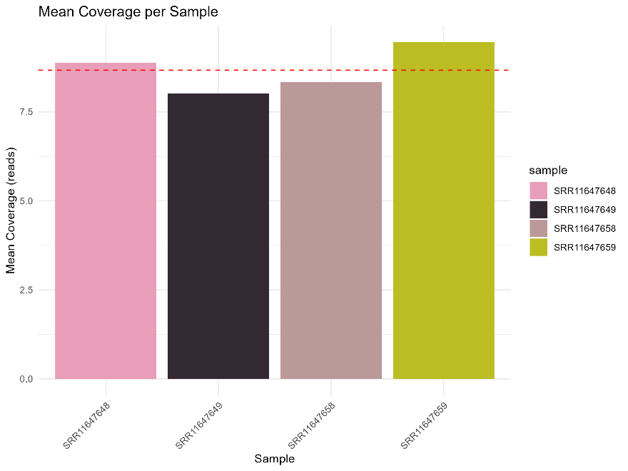
DMC calling
- Perform differentially methylated cytosine (DMC) analysis between your conditions.
- Save two lists of DMCs:
  - one using only statistical significance (e.g., adjusted p-value threshold),
  - one with both statistical significance and a methylation difference threshold (Δβ / Δmethylation).
- Report the total number of significant DMCs in both cases and briefly compare the results.

- Using a chromosome you like (or several), perform DMC calling using an R package you like (you can use DSS that we used) and using the Wilcoxon test. Create Venn diagram of overlap between the methods. Table comparing the number of DMCs, mean effect size. Which method is more conservative? Why?

- Threshold exploration. Test 4 combinations:
  - p<0.05, Δβ>0.1
  - p<0.01, Δβ>0.1
  - p<0.05, Δβ>0.2
  - p<0.01, Δβ>0.2
Create a comparison table. Plot: number of DMCs vs threshold stringency. Recommend best threshold for your data

- Extract promoter DMCs only. Compare with all DMCs: do you see different enrichment patterns? Are promoter DMCs more biologically meaningful?

- Create a volcano plot for DMCs. Explain the relationship between methylation difference and statistical significance.

- Create an MA plot (or equivalent):
  - x-axis: average methylation level,
  - y-axis: methylation difference.
Explain what happens at low coverage / extreme methylation levels.

DMR calling
- Identify differentially methylated regions (DMRs). Test at least 3 parameter sets (see below). Compare results (number of DMRs, length, and CpG density), choose optimal parameters set (you can use your own set if you see that it is better); and justify your decision.
  - minCG=3, minlen=50, p=0.05
  - minCG=5, minlen=100, p=0.01
  - minCG=7, minlen=200, p=0.01

- Characterize your DMRs. Show Length distribution, CpGs per DMR distribution, chromosome distribution, hyper vs hypo properties, density plot across genome, correlation between DMR length and effect size.

- Save a list of DMRs including:
  - genomic coordinates,
  - number of CpGs per region,
  - mean methylation difference,
  - statistical significance.
- Compare DMCs and DMR. Calculate and plot the number/fractions of DMCs falling within DMRs; number of isolated DMRs. Calculate enrichment in promoters, CGI).

- Create a heatmap of top DMCs and DMRs (most significant). Explain clustering patterns across samples.

Biological interpretation
- Perform functional enrichment analysis (e.g., GO, KEGG) using genes associated with DMRs and DMCs. You will have to investigate multiple variants (see next question)
- Compare and describe enrichment results obtained from:
  - all DMR-associated genes VS only promoter-associated DMR genes
  - Hypermethylated DMCs VS hypomethylated DMCs

- Compare and describe enrichment results obtained from the same type (like all or only promoter-associated):
  - DMCs
  - DMRs

- Interpret/describe top enriched pathways/terms and relate them to your experimental conditions. Do they match your biological question?

Conclusions
- Compare DMC vs DMR approaches:
  - advantages and limitations,
  - biological interpretability.

- Discuss how coverage and variability affect methylation analysis

- Write a paragraph where you describe your analysis methods (basically a paragraph or two for the Methods section in the article). Don’t forget that it must be short, and don’t forget citations.

- Write a “biological conclusions" section (up to 500 words). You should include:
Short introduction with your main biological question
Key findings (1-2 most interesting results)
Mechanism (propose how methylation changes affect biology)
Integration (connect DMC/DMR -> gene -> pathways -> phenotype)
Validation plan (1-2 experiments how to validate findings)
Limitations (any caveats?:))

